LAB MEMORANDUM _____11 June 1996_____CTEC, Inc.

SUBJECT: Characterization of Howard Johnson’s Magnetic Gate

1. Introduction: At the request of Mr. Howard Johnson (address deleted) CTEC, Inc has endeavored to test one of Mr. Johnson’s magnetic gates in order to determine the net force developed by such a gate and to document our test procedures and results. The tests were conducted at various times over the last 6 months, taking longer than expected due the non-availability of test personnel, the ordering and subsequent delay of delivery of the necessary force meter, and the development of a workable test procedure. With these problems solved the testing has been completed and the results are described below.

2. Objectives: the intent of this document is to describe the item that was tested, the test preparation and procedures, the data collected and the results obtained. Our conclusions are stated, and the test results are summarized.

3. Testing Process:

a. Item to be tested: for identification purposes we have labeled this gate the “HJMG1”. The HJMG1 consists of a series of very powerful neodenium permanent magnets aligned in a unique configuration on both sides of a model railroad track for a distance of approximately 24 inches. In addition there are rubber magnets fastened to the neodenium magnets that shield and divert the magnetic fields in such a way as to propel a model railroad car with magnets through the gate. This car is 7” long by 3” wide with the center of mass at the car’s center (plan view), and is referred to hereafter as the “magnet-car”. There is also a set of neodenium magnets (10” in length by 9” in width) underneath the center portion of the gate track that assist with the propulsion of the magnet-car. See Figure 1 for a plan view of the HJMG1 as it was received for testing.

b. Test preparation: prior to testing it was deemed necessary to strengthen the physical structure of the HJMG1 in order to stabilize the magnets with respect to the model railroad track. To accomplish the stabilization a plywood base (18”W x 50”L x ¾”D) with 2” x 4” cross members was constructed and placed beneath the magnetic gate, and all parts were fastened to the plywood base. Next, 3” brass screws were used to reinforce the wooden strips that hold the magnets in position along the track.

It was discovered in the preliminary tests that the model railroad track was too short to allow meter readings for the magnet-car as it approached and exited the gate. To fix this problem a temporary extension to the model railroad track of approximately 12” was constructed in front of the existing gate. See Figure 2, which shows the track extension and the magnet-car at the entry to the gate.
A similar track extension was constructed at the exit end of the gate.

To provide a level run for the magnet-car, 4 leveling bolts (3/8” diameter) were mounted near the corners of the plywood base and extending through the plywood (0 – 1”). The plywood base was placed on a table, so that the leveling bolts extended through the plywood base bearing on the table. A level bubble was mounted on a small board and placed upon the track, so that the level bubble could be moved along the track and the leveling bolts could be adjusted to insure that entire length of track was level prior to running the tests.

c. Test Procedures: the force meter was mounted to accommodate readings along the entire track (totaling nearly 4 feet in length), using both tension and compression readings. See Attachment 1, which describes the make, model and specifications for the force meter. For the gate readings between the magnets, the meter was screwed to a small board, which in turn was screwed to the wooden roadbed beneath the track well in front of the gate. This arrangement worked well for about 23.5” of the track, where the magnets were mounted along the track and the gate action pulled the magnet-car through the gate. See Figure 3, which shows the entry track extension, magnet-car and the force meter. Readings were taken every ½” by using a strong nylon string to connect the force meter to the magnet-car. The string was doubled back under the magnet-car and fastened to a special “quick release” tie-down, so that the magnet-car could be easily moved for each set of readings.

However, for about 10.5” in front of the gate, the magnet-car was repulsed by the gate, and the force meter was read in compression. To handle this situation the force meter was held by a heavy rubber tie-down strap, which allowed it to be moved frequently, so that readings could be recorded every ½” in front of the gate. A special metal rod that came with the force meter was used to connect to the magnet-car.

For the 13” of track at the gate exit, the magnet-car was attracted by the gate magnets, and the force meter was read in tension mode, using a special rod with hook that came with the force meter. The hook was placed on the lead axle of the magnet-car, and the force meter was held by a heavy rubber tie-down strap, so that readings could be recorded every ½”, as the magnet-car was pulled away from the gate exit.

d. Collecting the data: the amount of data to collect was determined by preliminary tests that showed ½” intervals to be close enough together, so that large peaks or valleys in the force readings would not be missed. One inch intervals might have allowed significant data peaks or valleys to be omitted, and therefore, data was collected at ½” intervals.

The data collection started at zero force 10.5” in front of the first magnets in the gate, increasing in compression and falling to zero force at the gate entrance. As the magnet-car proceeds into the gate between the magnets, the force increases in tension and varies through the gate for about 23.5”, until the force on the magnet-car returns to zero very close to the last magnets in the gate. At this point there was another force inversion, and the magnet-car was attracted by the gate magnets for the next 13 inches. At a point 47” from the starting point the force on the magnet-car returned to zero.

Also, it was determined that the force meter was extremely sensitive to variations in force caused by small vibrations or minute changes in the magnet-car’s alignment. For example, the model railroad wheel assemblies would allow a small amount of skew in the magnet-car, which was enough to change the second and third decimal place force meter readings by as much as +/- 5%. To compensate for these unavoidable variations in force meter readings, five force meter readings were taken at each ½” interval and averaged to give a suitable value for each interval.

The five force meter values were obtained by zeroing the force meter, allowing the first tension or compression reading to stabilize for 5-10 seconds, and then recording the first value in the spreadsheet. The second force meter reading was obtained by moving the magnet-car in a direction that allowed the meter to return to zero and then re-applying the tension or compression and allowing the meter reading to again stabilize. This reading was recorded as the second reading, and the process was repeated three more times to complete the set of five force meter readings at each ½” distance interval. The back end of the magnet-car was used as the reference point for each of the force meter readings.

d. Data collected: a spreadsheet was used to record five force meter values at each ½ ” interval for 47”, making a total of 475 data readings. See Table 1. A description of the column headings for Table 1 is shown below:

Column ID Column Title Column Description

A Point # Data row number

B Distance into Gate (inches) Distance from zero point (using ½” increments)

C Force1 on car (lbs.) Force on magnet-car,
D Force2 on car (lbs.) which was recorded five
E Force3 on car (lbs.) times for each ½”
F Force4 on car (lbs.) internal from the zero
G Force5 on car (lbs.) point

Column ID Column Title Column Description

H Average Force on Car (lbs.) Sum(Forces1-5)/5

I Area under Force-Distance Area in lb.-inches, using
Curve trapezoidal integration

Columns A through G recorded the raw data obtained during the testing process. Column H was computed from columns C through G by summing the five forces at each ½” increment and dividing by five to get the average force. This was done to compensate for the errors that might occur from the highly sensitive force meter, which was shown to vary as much as +/- 5% due the non-linearity of the magnets and the slight skew effect of the model railroad magnet-car. Column I was computed from Column H, using a standard trapezoidal integration technique. The TOTALS row at the end of Table 1 shows the arithmetic sum for each column C through I.

- Results: the testing process as described above yielded a net cumulative gain of 7.8993 lb.-inches (TOTALS row, Column I, Table 1), taking into account the negative forces present at the entry and exit areas of the magnetic gate, as well as the positive forces exerted on the magnet-car. A graphic of these effects is shown in Figure 4, which is a plot of the “Average Force on Car” (lbs.) [Column H, Table 1] versus the “Distance into Gate (inches)” [Column B, Table1]. If the net gain of 7.8993 lb.-inches is divided by the distance-into-gate interval of 0.5 inches, a net force of “15.7986 lbs.” is obtained. This agrees with the arithmetic sum of Column H, Table 1, which was “15.7986 lbs.”.

In Figure 4 the plot shows three distinct areas of interest from left to right, namely the entry portion (negative force), the gate portion (positive force) and the exit portion (negative force). By taking the data in Column H of Table 1 and summing the average forces corresponding to these respective portions, the following chart results:

Area of Interest Force Cumulative (lbs.)
Entry -8.3196
Gate 34.3030
Exit -10.1848
TOTAL 15.7986

5. Conclusions: it is significant to remember that there are no external inputs to the HJMG1, and all magnets used to construct the gate and the magnet-car are of the permanent type. It is apparent that a net cumulative gain of 7.8993 lb.-inches (or nearly 8 lb.-inches) is produced by the interactions between the magnetic gate and the magnet-car. In terms of pure force produced by the magnetic gate, a net cumulative force of 15.7986 lbs. is generated, i.e. nearly 16 lbs. The individual forces of course are much smaller, varying between minus 1.0118 and plus 1.4254 lbs.

Reference is made to Figure 4, which is a plot of the “Average Force on Car” (lbs.) versus the “Distance into Gate (inches). It is clear that the negative forces are only generated outside the gate magnets at both ends of the gate in the areas that have been identified as the “entry” and “exit” portions of the gate. Furthermore, it is noted that the positive forces are generated by the gate’s center portion, where the gate magnets line both sides of the track. These conditions suggest that if the gate magnets were extended to form a complete circle, either in the vertical or horizontal plane, the negative forces might be eliminated or at least attenuated to a lower level. Ideally, the elimination of the negative forces would suggest that a permanent magnet motor would be feasible, unless additional compensatory phenomena are encountered. Investigation of the further phenomenology of circular track configurations is recommended.

6. Questions and Comments: call or write CTEC, Inc., 2311 Big Cove Road, Huntsville, AL 35801 [256.533.3682]

Respectfully submitted: Approved:

Kenneth D. Moore Thomas E. Bearden
Kenneth D. Moore Thomas E. Bearden
Test Engineer, CTEC, Inc. President and CEO, CTEC, Inc.

Figure: 1- Howard Johnson’s Magnetic Gate
2- Howard Johnson’s Magnetic Gate with Track Extension and
Magnet-Car
3- Howard Johnson’s Magnetic Gate with Track Extension, Magnet-
Car and Force Meter
4- Average Force on Magnet-Car vs. Distance into Gate

Table: 1- Test Data for HJMG1

Attachment: 1- Force meter specifications
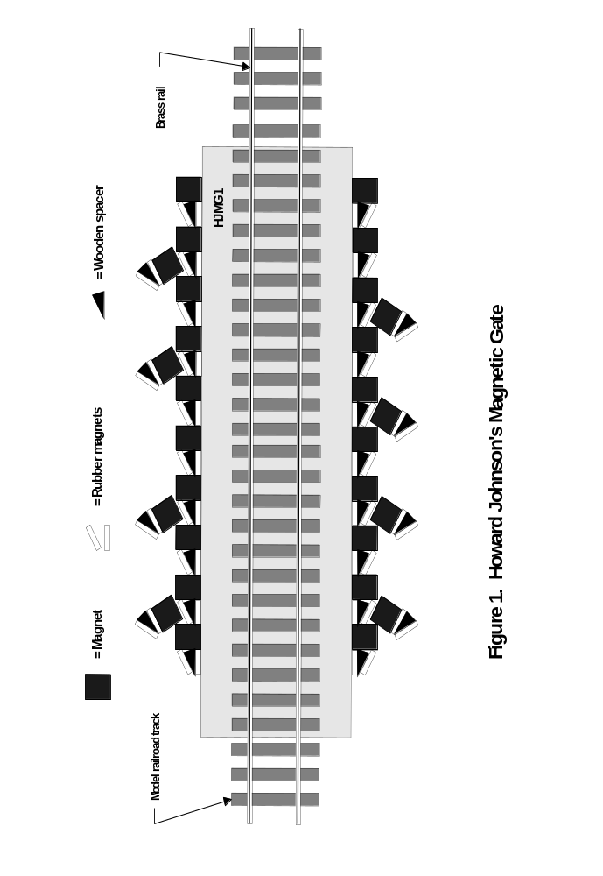
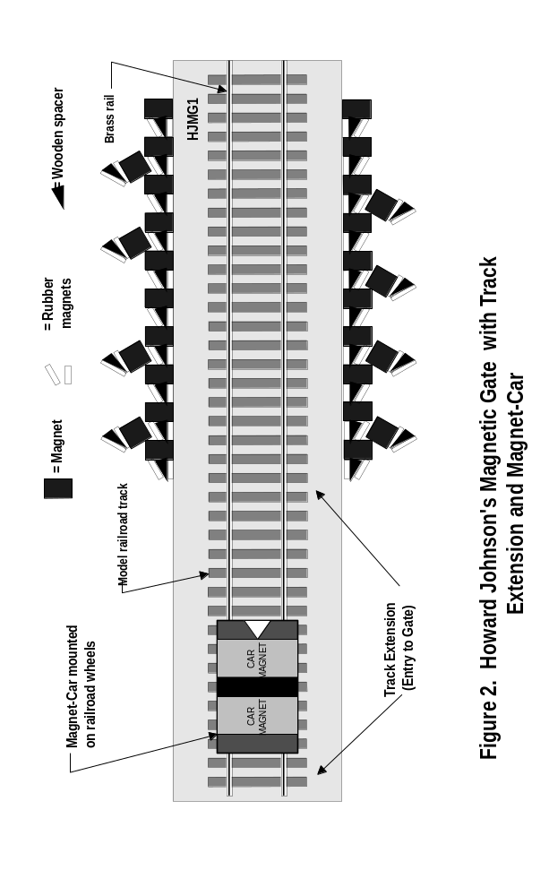
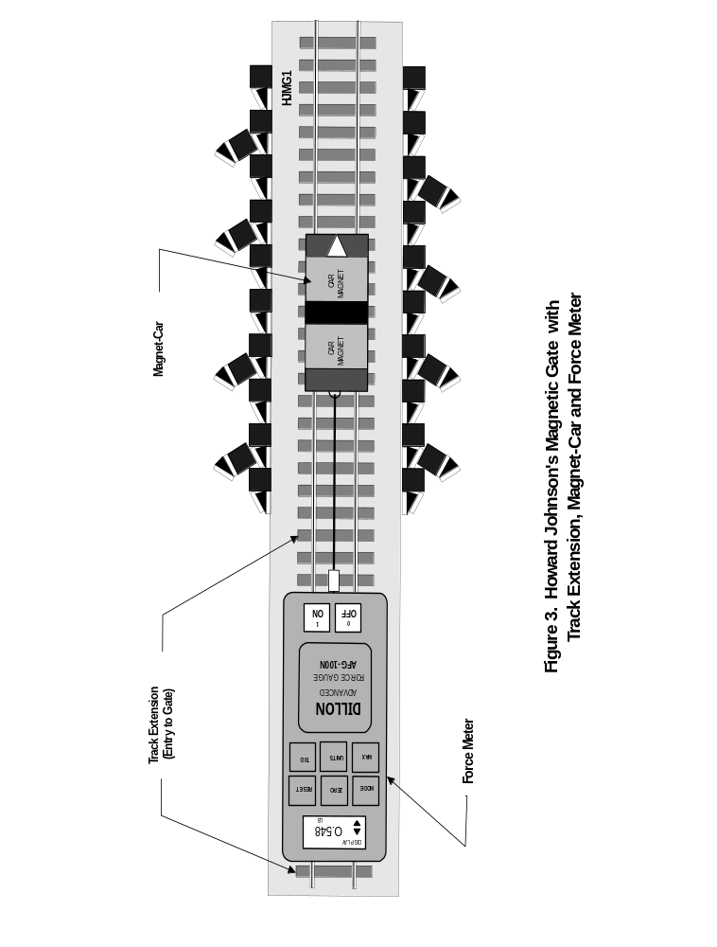
Table 1. Test Data for Howard Johnson's Magnetic Gate (HJMG1)
Point # | Distance into Gate (inches) | Force1 on Car (lbs.) | Force2 on Car (lbs.) | Force3 on Car (lbs.) | Force4 on Car (lbs.) | Force5 on Car (lbs.) | Average Force on Car (lbs.) | Area under Force-Distance Curve
1 | 0.00 | 0.000 | 0.000 | 0.000 | 0.000 | 0.000 | 0.0000 | 0.0000
2 | 0.50 | -0.061 | -0.057 | -0.057 | -0.057 | -0.057 | -0.0578 | -0.0145
3 | 1.00 | -0.057 | -0.052 | -0.057 | -0.052 | -0.061 | -0.0558 | -0.0284
4 | 1.50 | -0.185 | -0.189 | -0.176 | -0.180 | -0.185 | -0.1830 | -0.0597
5 | 2.00 | -0.123 | -0.119 | -0.105 | -0.106 | -0.105 | -0.1116 | -0.0737
6 | 2.50 | -0.149 | -0.154 | -0.149 | -0.154 | -0.158 | -0.1528 | -0.0661
7 | 3.00 | -0.224 | -0.224 | -0.220 | -0.216 | -0.220 | -0.2208 | -0.0934
8 | 3.50 | -0.242 | -0.233 | -0.238 | -0.229 | -0.229 | -0.2342 | -0.1138
9 | 4.00 | -0.277 | -0.273 | -0.264 | -0.260 | -0.251 | -0.2650 | -0.1248
10 | 4.50 | -0.326 | -0.343 | -0.335 | -0.348 | -0.339 | -0.3382 | -0.1508
11 | 5.00 | -0.396 | -0.388 | -0.392 | -0.396 | -0.414 | -0.3972 | -0.1839
12 | 5.50 | -0.454 | -0.449 | -0.454 | -0.445 | -0.454 | -0.4512 | -0.2121
13 | 6.00 | -0.562 | -0.557 | -0.567 | -0.564 | -0.571 | -0.5642 | -0.2539
14 | 6.50 | -0.634 | -0.630 | -0.634 | -0.639 | -0.621 | -0.6316 | -0.2990
15 | 7.00 | -0.718 | -0.727 | -0.731 | -0.714 | -0.723 | -0.7226 | -0.3386
16 | 7.50 | -0.789 | -0.771 | -0.767 | -0.806 | -0.758 | -0.7782 | -0.3752
17 | 8.00 | -0.842 | -0.850 | -0.855 | -0.833 | -0.837 | -0.8434 | -0.4054
18 | 8.50 | -0.833 | -0.815 | -0.828 | -0.824 | -0.820 | -0.8240 | -0.4169
19 | 9.00 | -0.731 | -0.723 | -0.718 | -0.714 | -0.709 | -0.7190 | -0.3858
20 | 9.50 | -0.520 | -0.515 | -0.529 | -0.524 | -0.511 | -0.5198 | -0.3097
21 | 10.00 | -0.251 | -0.255 | -0.242 | -0.260 | -0.238 | -0.2492 | -0.1923
22 | 10.50 | 0.000 | 0.000 | 0.000 | 0.000 | 0.000 | 0.0000 | -0.0623
23 | 11.00 | 0.423 | 0.414 | 0.41 | 0.418 | 0.436 | 0.4202 | 0.1051
24 | 11.50 | 0.529 | 0.546 | 0.533 | 0.533 | 0.529 | 0.5340 | 0.2386
25 | 12.00 | 0.555 | 0.595 | 0.604 | 0.573 | 0.582 | 0.5818 | 0.2790
26 | 12.50 | 0.679 | 0.599 | 0.621 | 0.692 | 0.612 | 0.6406 | 0.3056
27 | 13.00 | 0.908 | 0.925 | 0.934 | 0.952 | 0.908 | 0.9254 | 0.3915
28 | 13.50 | 1.168 | 1.084 | 1.155 | 1.190 | 1.203 | 1.1600 | 0.5214
29 | 14.00 | 1.472 | 1.437 | 1.463 | 1.406 | 1.349 | 1.4254 | 0.6464
30 | 14.50 | 1.388 | 1.371 | 1.375 | 1.366 | 1.384 | 1.3768 | 0.7006
31 | 15.00 | 1.300 | 1.327 | 1.362 | 1.336 | 1.305 | 1.3260 | 0.6757
32 | 15.50 | 1.234 | 1.181 | 1.186 | 1.155 | 1.137 | 1.1786 | 0.6262
33 | 16.00 | 0.925 | 0.895 | 0.903 | 0.952 | 0.917 | 0.9184 | 0.5243
34 | 16.50 | 0.709 | 0.692 | 0.674 | 0.674 | 0.745 | 0.6988 | 0.4043
35 | 17.00 | 0.537 | 0.595 | 0.529 | 0.555 | 0.502 | 0.5436 | 0.3106
36 | 17.50 | 0.418 | 0.462 | 0.449 | 0.507 | 0.449 | 0.4570 | 0.2502
37 | 18.00 | 0.414 | 0.388 | 0.374 | 0.365 | 0.361 | 0.3804 | 0.2094
38 | 18.50 | 0.533 | 0.537 | 0.546 | 0.555 | 0.542 | 0.5426 | 0.2308
39 | 19.00 | 0.639 | 0.634 | 0.639 | 0.634 | 0.692 | 0.6476 | 0.2976
40 | 19.50 | 0.656 | 0.648 | 0.661 | 0.639 | 0.652 | 0.6512 | 0.3247
Table 1. Test Data for Howard Johnson's Magnetic Gate (HJMG1)
Point # | Distance into Gate (inches) | Force1 on Car (lbs) | Force2 on Car (lbs) | Force3 on Car (lbs) | Force4 on Car (lbs) | Force5 on Car (lbs) | Average Force on Car (lbs) | Area under Force-Distance Curve
41 | 20.00 | 0.582 | 0.595 | 0.586 | 0.612 | 0.590 | 0.5930 | 0.3111
42 | 20.50 | 0.476 | 0.507 | 0.493 | 0.524 | 0.462 | 0.4924 | 0.2714
43 | 21.00 | 0.423 | 0.436 | 0.449 | 0.436 | 0.432 | 0.4352 | 0.2319
44 | 21.50 | 0.396 | 0.414 | 0.392 | 0.401 | 0.405 | 0.4016 | 0.2092
45 | 22.00 | 0.343 | 0.348 | 0.357 | 0.352 | 0.352 | 0.3504 | 0.1880
46 | 22.50 | 0.41 | 0.414 | 0.392 | 0.388 | 0.383 | 0.3974 | 0.1870
47 | 23.00 | 0.379 | 0.392 | 0.383 | 0.379 | 0.374 | 0.3814 | 0.1947
48 | 23.50 | 0.383 | 0.392 | 0.396 | 0.405 | 0.383 | 0.3918 | 0.1933
49 | 24.00 | 0.388 | 0.396 | 0.392 | 0.401 | 0.392 | 0.3938 | 0.1964
50 | 24.50 | 0.436 | 0.432 | 0.427 | 0.432 | 0.423 | 0.4300 | 0.2060
51 | 25.00 | 0.498 | 0.507 | 0.471 | 0.467 | 0.471 | 0.4828 | 0.2282
52 | 25.50 | 0.568 | 0.595 | 0.590 | 0.586 | 0.595 | 0.5868 | 0.2674
53 | 26.00 | 0.670 | 0.696 | 0.718 | 0.692 | 0.723 | 0.6998 | 0.3217
54 | 26.50 | 0.767 | 0.806 | 0.784 | 0.806 | 0.802 | 0.7930 | 0.3732
55 | 27.00 | 0.828 | 0.824 | 0.811 | 0.824 | 0.842 | 0.8258 | 0.4047
56 | 27.50 | 0.855 | 0.824 | 0.828 | 0.837 | 0.802 | 0.8292 | 0.4138
57 | 28.00 | 0.85 | 0.864 | 0.868 | 0.877 | 0.846 | 0.8610 | 0.4226
58 | 28.50 | 0.881 | 0.877 | 0.877 | 0.886 | 0.877 | 0.8796 | 0.4352
59 | 29.00 | 0.992 | 1.000 | 1.014 | 1.031 | 1.027 | 1.0128 | 0.4731
60 | 29.50 | 1.102 | 1.128 | 1.124 | 1.115 | 1.137 | 1.1212 | 0.5335
61 | 30.00 | 1.150 | 1.199 | 1.194 | 1.225 | 1.234 | 1.2004 | 0.5804
62 | 30.50 | 1.106 | 1.102 | 1.128 | 1.124 | 1.133 | 1.1186 | 0.5798
63 | 31.00 | 1.080 | 1.106 | 1.089 | 1.115 | 1.102 | 1.0984 | 0.5543
64 | 31.50 | 1.106 | 1.097 | 1.146 | 1.142 | 1.133 | 1.1248 | 0.5558
65 | 32.00 | 1.115 | 1.106 | 1.159 | 1.128 | 1.181 | 1.1378 | 0.5657
66 | 32.50 | 0.934 | 0.93 | 0.939 | 0.934 | 0.925 | 0.9324 | 0.5176
67 | 33.00 | 0.648 | 0.643 | 0.630 | 0.626 | 0.621 | 0.6336 | 0.3915
68 | 33.50 | 0.295 | 0.321 | 0.326 | 0.282 | 0.224 | 0.2896 | 0.2308
69 | 34.00 | 0.000 | 0.000 | 0.000 | 0.000 | 0.000 | 0.0000 | 0.0724
70 | 34.50 | -0.145 | -0.132 | -0.154 | -0.127 | -0.123 | -0.1362 | -0.0341
71 | 35.00 | -0.251 | -0.291 | -0.277 | -0.299 | -0.286 | -0.2808 | -0.1043
72 | 35.50 | -0.370 | -0.392 | -0.352 | -0.396 | -0.383 | -0.3786 | -0.1649
73 | 36.00 | -0.524 | -0.507 | -0.471 | -0.458 | -0.462 | -0.4844 | -0.2158
74 | 36.50 | -0.568 | -0.586 | -0.582 | -0.573 | -0.590 | -0.5798 | -0.2661
75 | 37.00 | -0.828 | -0.824 | -0.820 | -0.837 | -0.820 | -0.8258 | -0.3514
76 | 37.50 | -0.917 | -0.934 | -0.930 | -0.932 | -0.934 | -0.9294 | -0.4388
77 | 38.00 | -1.005 | -1.009 | -1.031 | -1.014 | -1.000 | -1.0118 | -0.4853
78 | 38.50 | -0.956 | -0.978 | -1.067 | -0.952 | -0.974 | -0.9854 | -0.4993
79 | 39.00 | -0.806 | -0.828 | -0.842 | -0.846 | -0.811 | -0.8266 | -0.453
80 | 39.50 | -0.718 | -0.723 | -0.727 | -0.723 | -0.727 | -0.7236 | -0.3876
Table 1. Test Data for Howard Johnson's Magnetic Gate (HJMG1)
Point # | Distance into Gate (inches) | Force1 on Car (lbs) | Force2 on Car (lbs) | Force3 on Car (lbs) | Force4 on Car (lbs) | Force5 on Car (lbs) | Average Force on Car (lbs) | Area under Force-Distance Curve
81 | 40.00 | -0.590 | -0.582 | -0.595 | -0.573 | -0.577 | -0.5834 | -0.3268
82 | 40.50 | -0.476 | -0.480 | -0.489 | -0.485 | -0.479 | -0.4818 | -0.2663
83 | 41.00 | -0.427 | -0.440 | -0.434 | -0.445 | -0.436 | -0.4364 | -0.2296
84 | 41.50 | -0.352 | -0.361 | -0.357 | -0.379 | -0.361 | -0.3620 | -0.1996
85 | 42.00 | -0.321 | -0.326 | -0.335 | -0.321 | -0.339 | -0.3284 | -0.1726
86 | 42.50 | -0.194 | -0.198 | -0.224 | -0.196 | -0.202 | -0.2028 | -0.1328
87 | 43.00 | -0.145 | -0.149 | -0.145 | -0.149 | -0.154 | -0.1484 | -0.0878
88 | 43.50 | -0.101 | -0.092 | -0.110 | -0.101 | -0.110 | -0.1028 | -0.0628
89 | 44.00 | -0.083 | -0.092 | -0.083 | -0.079 | -0.088 | -0.0850 | -0.0470
90 | 44.50 | -0.079 | -0.079 | -0.083 | -0.088 | -0.079 | -0.0816 | -0.0417
91 | 45.00 | -0.074 | -0.070 | -0.074 | -0.072 | -0.079 | -0.0738 | -0.0389
92 | 45.50 | -0.070 | -0.061 | -0.057 | -0.066 | -0.057 | -0.0622 | -0.034
93 | 46.00 | -0.048 | -0.044 | -0.046 | -0.044 | -0.048 | -0.0460 | -0.0271
94 | 46.50 | -0.030 | -0.026 | -0.022 | -0.026 | -0.035 | -0.0278 | -0.0185
95 | 47.00 | 0.000 | 0.000 | 0.000 | 0.000 | 0.000 | 0.0000 | -0.0070
 | TOTALS | 15.696 | 15.753 | 15.756 | 16.027 | 15.761 | 15.7986 | 7.8993

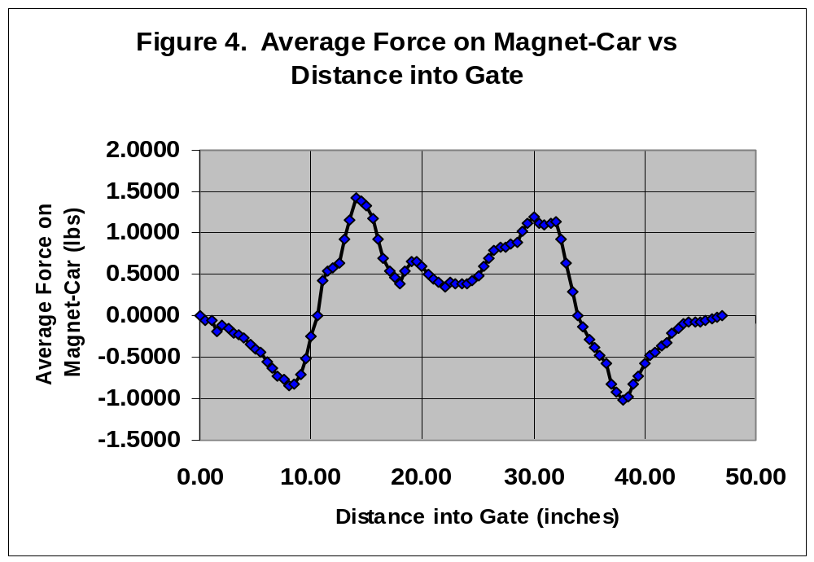

ATTACHMENT 1: Force Meter Specifications for the Dillon AFG100N

Units of measurement and resolutions are rounded up to nearest resolving digit.

On each range, actual resolution is user selectable at 1 Part in 5,000 or 1 Part in 300 of full scale. Resolutions quoted above are at 1 part in 5,000.

Capacities: lbs. oz. N g

22x0.005 350x0.07 100x0.02 10,000x2

Data capture rate: 1200 Hz

Display update rates: Hi: 40 Hz; Low: 2 Hz

Accuracy: ±0. 1 % of full scale ± 1 least significant digit

Display features: 1st and ultimate peak capture, pass/fail alarms; freeze reading.

On external contact (make or break) at 120Ohz

Display overload: Typically 120% of full scale. Auto power off. User-configurable.

Battery life: 16 hours continuous use between charges

Outputs: Configurable RS-232, Mitutoyo and analog

Calibration temperature: 20'C + 2'C

Display weight: 1 lb. 5 oz. (640g)

Test stand connection: The AFG commands (via correct cable) a Dillon
motorized test stand to reverse on sample break or preset alarm.

Accessories: Wide range of fixtures, cables and other accessories available.
